Blank Guess Who Game

Instructions

**Creation instructions:**

1. Create your 24 characters. Start with the A3 game board to create 24 characters by colouring in the outlines. Be as creative as you like, the outlines are just an idea to get you started. You can lengthen hair, change facial hair, add glasses etc.
2. Give all 24 characters a name.
3. Then, replicate your 24 characters onto your two A4 game boards.
4. Now, replicate your 24 characters onto your green character cards.

**What you need to play:**

* A3 game board sheet
* counters or markers to mark off your A3 game board sheet
* 24-character cards
* 24-character cards to select your characters

**How to play**

* The game needs 2 players.
* Each player picks a character card without looking.
* Using the mat as a reference, take it in turns asking each other questions to find out who is on the other player's card.
* Mark off the characters on your board as they are eliminated, using a whiteboard marker or a counter if your board isn’t laminated.

Guess Who?

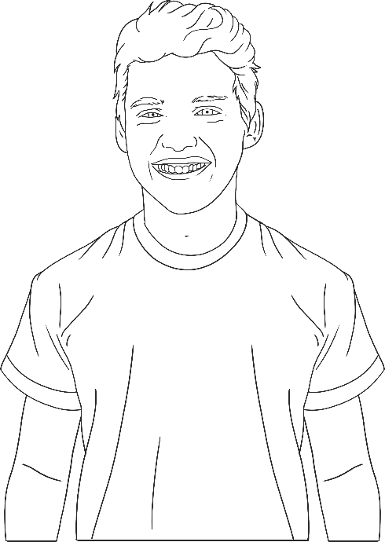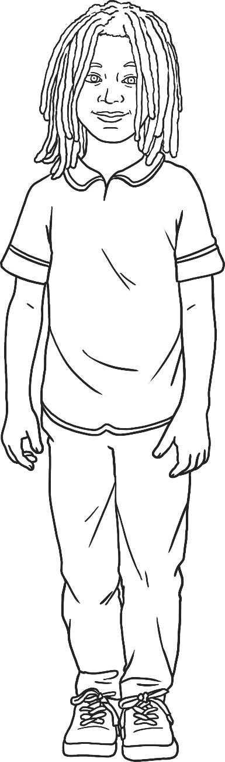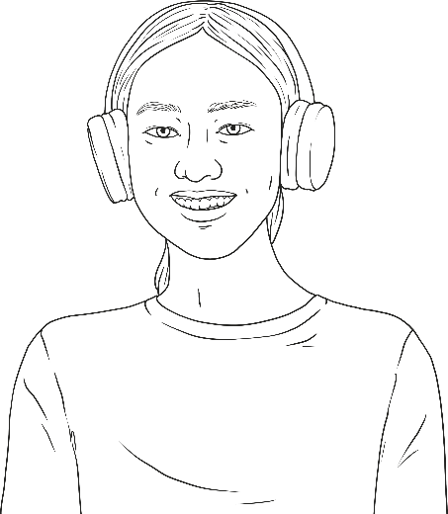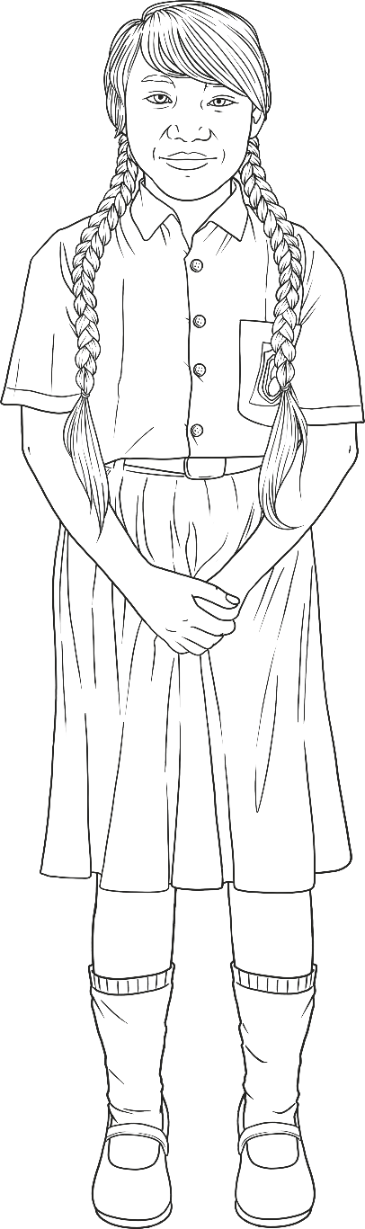

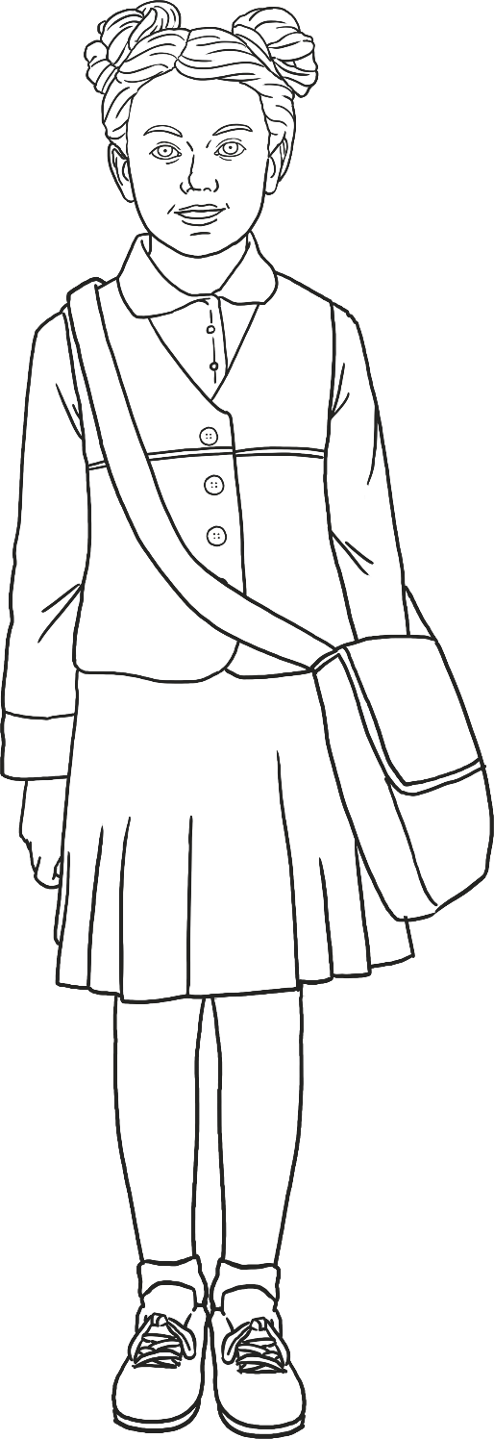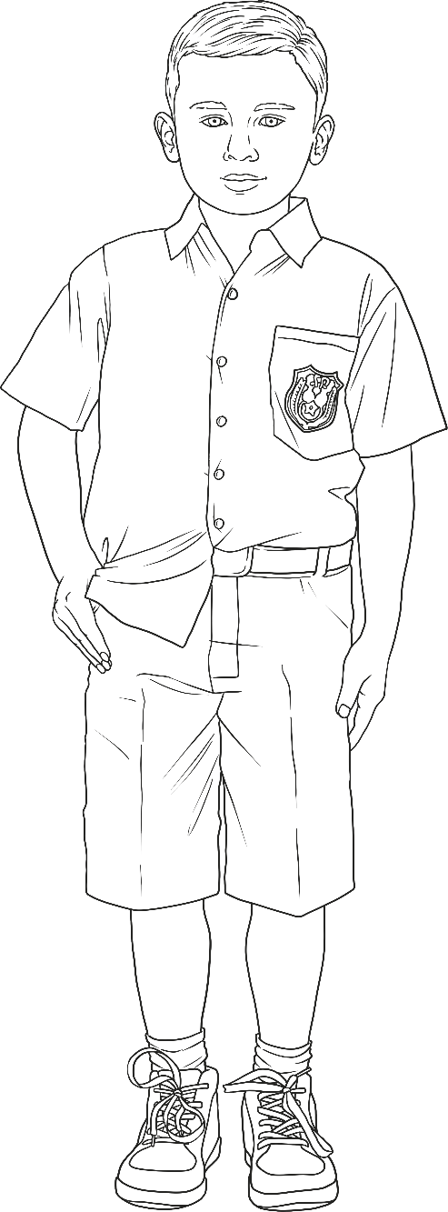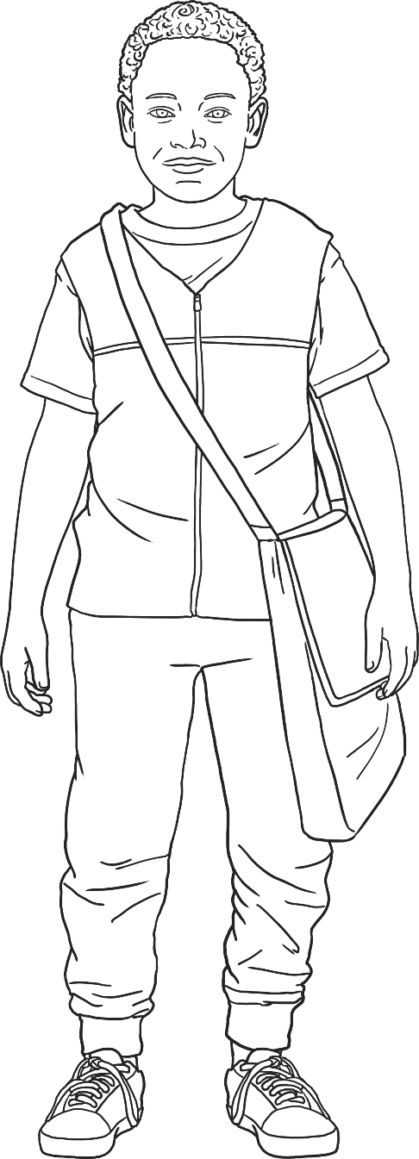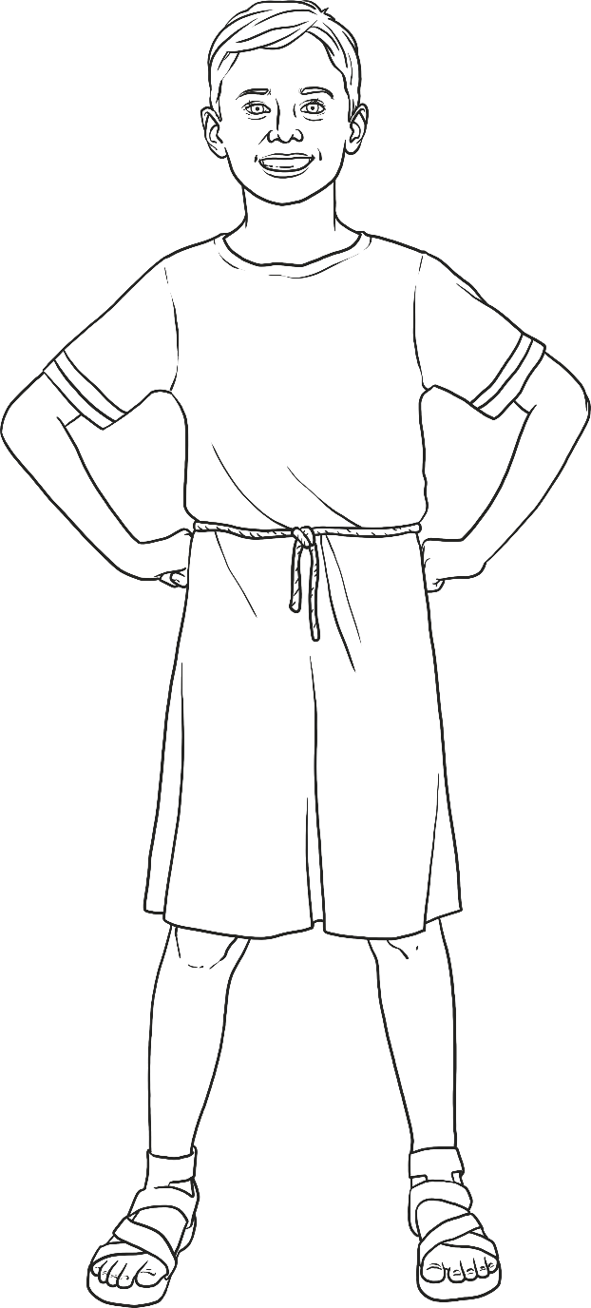

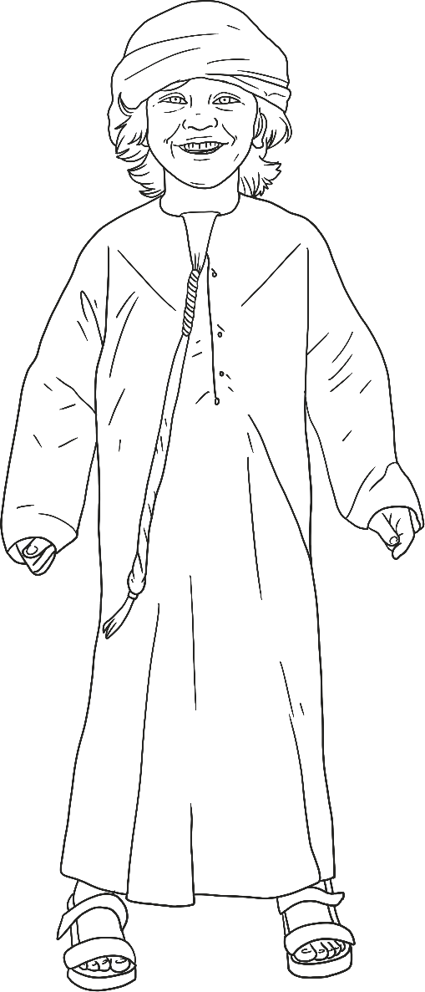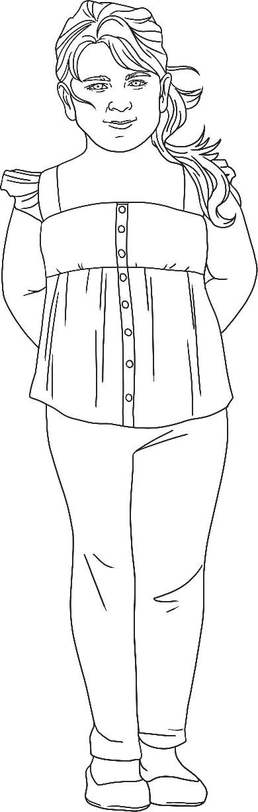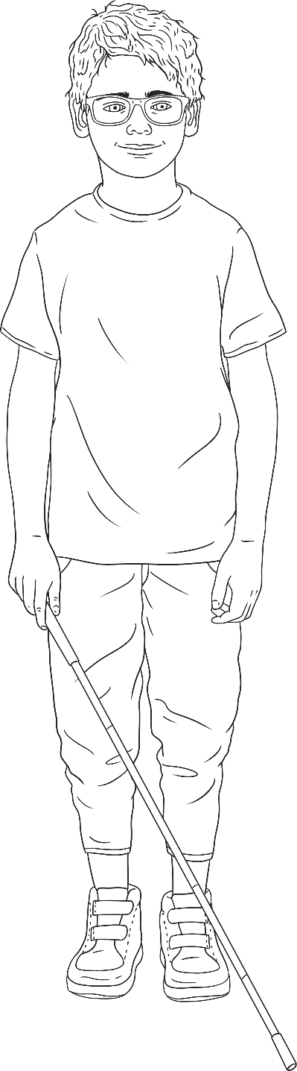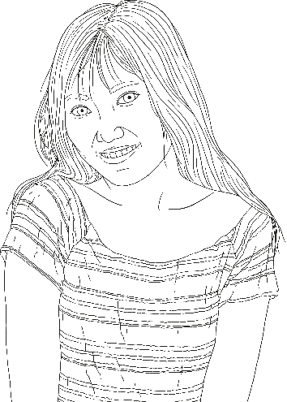

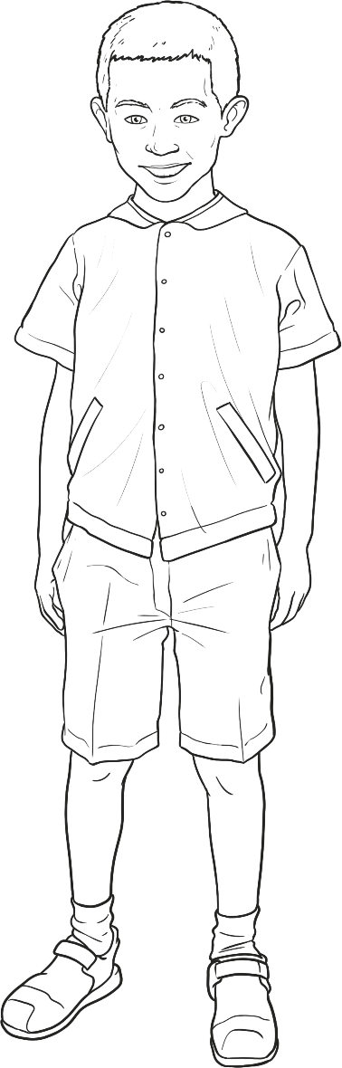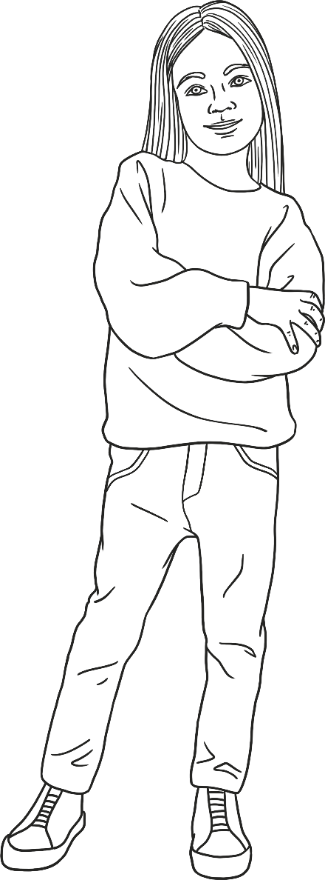

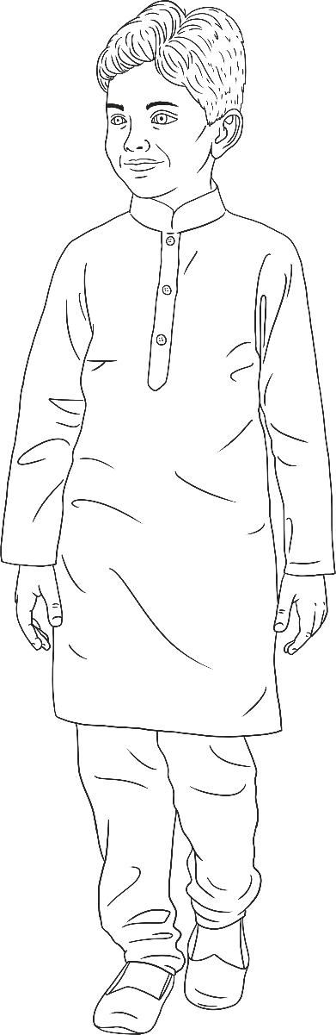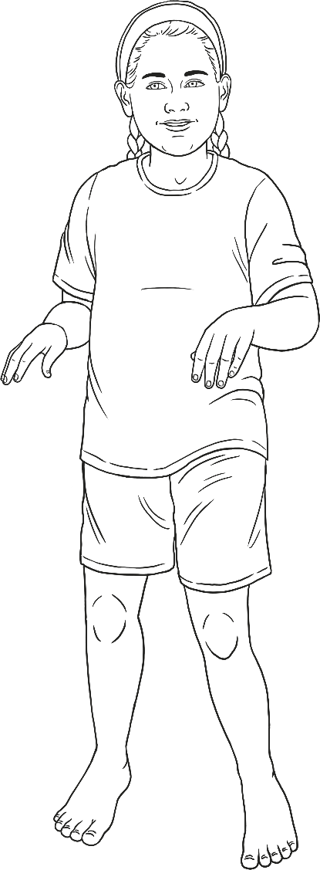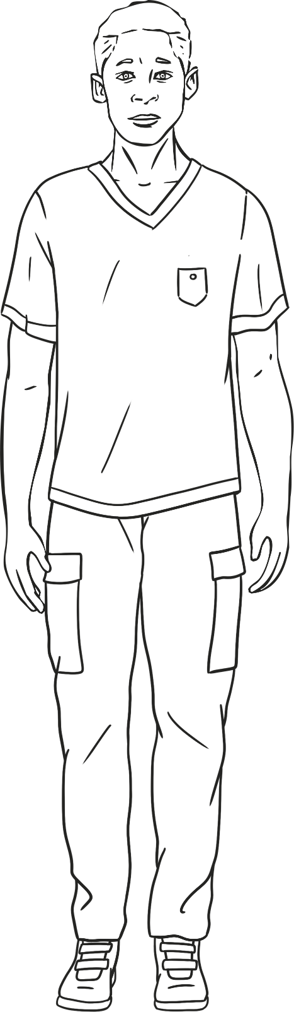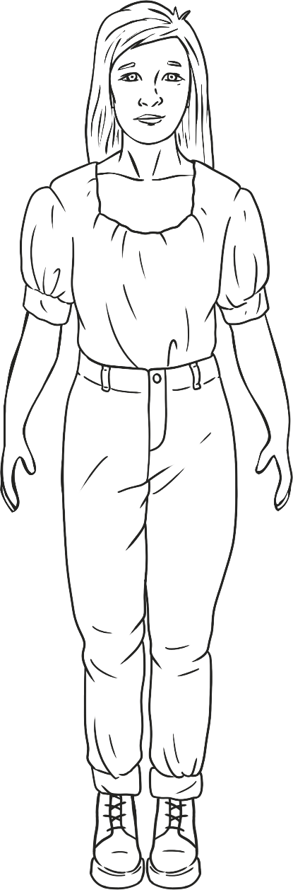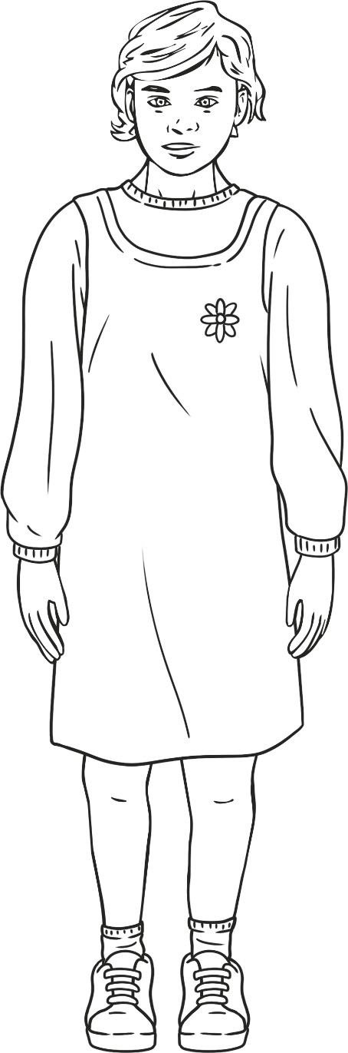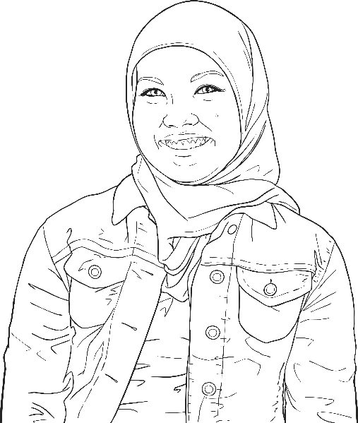

Guess Who?







